**Suggested Social Media posts:**

J

oin us in raising awareness about stopping sexual violence before it starts by sharing posts on social networking sites. Here are suggested social media posts and images that you may copy and paste, or visit the [Wyoming Coalition Against Domestic Violence and Sexual Assault](https://www.facebook.com/pages/Wyoming-Coalition-Against-Domestic-Violence-and-Sexual-Assault/293099254045098?fref=ts) Facebook page to share our posts.

**_________________________________________________________________**

The WCADVSA is excited to launch the Wyoming BE THE SOLUTION campaign to raise awareness that sexual violence is perpetrated in Wyoming, but there are actions we can take to prevent it from happening in the first place. Visit [www.bethesolutionwyo.org](http://www.bethesolutionwyo.org) to learn more about how you can BE THE SOLUTION.

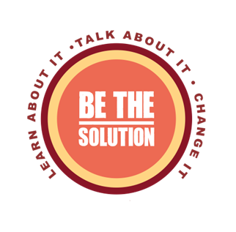

**_________________________________________________________________**

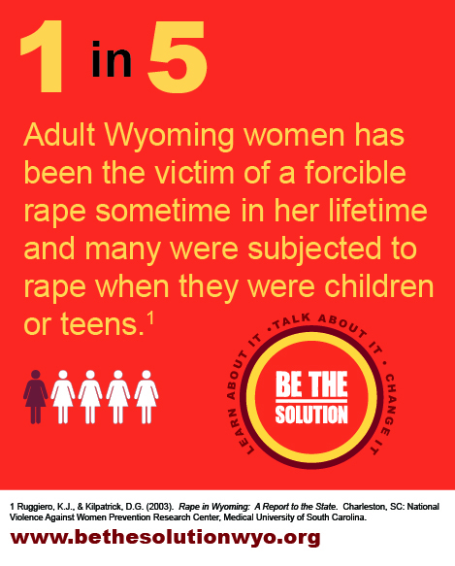[Learn About It:](http://www.bethesolutionwyo.org/#!learn-about-it/c1sr) Sexual violence is happening across Wyoming. Take the time to learn about sexual violence and how our attitudes about it influence others. Visit [www.bethesolutionwyo.org](http://www.bethesolutionwyo.org) to learn more about how you can BE THE SOLUTION.

**_________________________________________________________________**

Learn About It: Sexual violence is happening across Wyoming. Take the time to learn about sexual violence and how our attitudes about it influence others. Visit [www.bethesolutionwyo.org](http://www.bethesolutionwyo.org) to learn more about how you can BE THE SOLUTION.

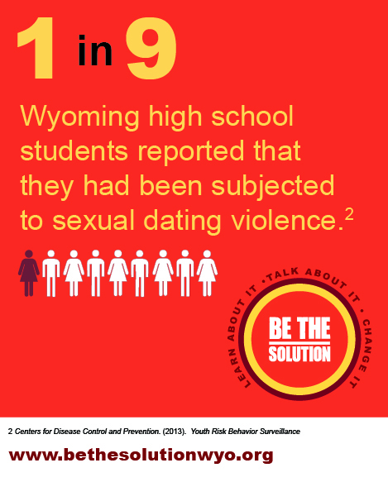

**_________________________________________________________________**

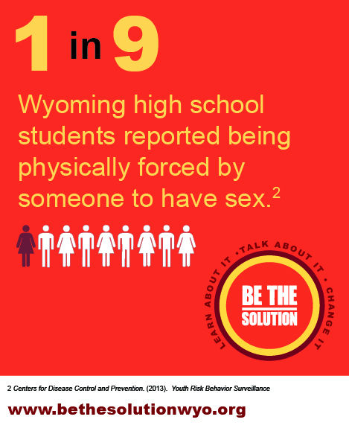[Learn About It:](http://www.bethesolutionwyo.org/#!learn-about-it/c1sr) Sexual violence is happening across Wyoming. Take the time to learn about sexual violence and how our attitudes about it influence others. Visit [www.bethesolutionwyo.org](http://www.bethesolutionwyo.org) to learn more about how you can BE THE SOLUTION.

**_________________________________________________________________**

Talk About it: ​Conversations can focus on healthy relationships and sexuality with our youth, and have these conversations early on and often; why phrases like "boys will be boys" and "you throw like a girl" are harmful; the impact of violence shown on television and video games with kids; and how sexual violence affects your community. Visit [www.bethesolutionwyo.org](http://www.bethesolutionwyo.org) to learn more about how you can BE THE SOLUTION.

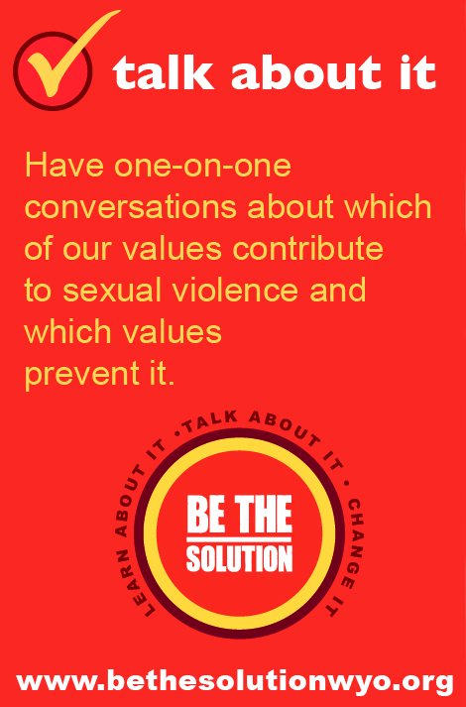

**_________________________________________________________________**

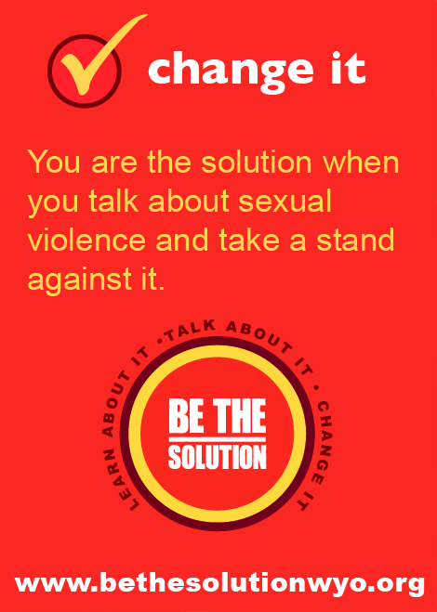[Change it:](http://www.bethesolutionwyo.org/#!change-it/c11ij) You are the solution when you talk about sexual violence and take a stand against it. Call out others when they make or laugh at sexist jokes; acknowledge that discriminatory behavior and language are connected to sexual violence; and spread the message throughout your community that sexual violence is never okay. Visit [www.bethesolutionwyo.org](http://www.bethesolutionwyo.org) to learn more about how you can BE THE SOLUTION.

**______________________________________________________________**

Change it: Keep learning about sexual violence. Bring the problem up in conversations and challenge values that create unhealthy behaviors. You can lead the change. Visit [www.bethesolutionwyo.org](http://www.bethesolutionwyo.org) to learn more about how you can BE THE SOLUTION.

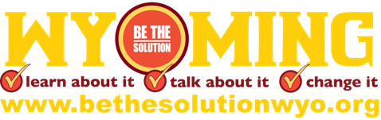

**_________________________________________________________________**

**Connect with us!**

Follow us on Twitter at @WCADVSA

Email [edeegan@wyomingdvsa.org](mailto:edeegan@wyomingdvsa.org) to share your BTS events

Change your profile picture to show that you will BE THE SOLUTION

Post your own ideas for how you can BE THE SOLUTION using #bethesolutionwyo

This product was supported by Grant No. 2012-WR-AX-0016 awarded by the Office on Violence Against Women, U.S. Department of Justice.  The opinions, findings, conclusions, and recommendations expressed in this publication are those

of the author(s) and do not necessarily reflect the views of the Department of Justice, Office on Violence Against Women.