**Suggested Social Media posts:**

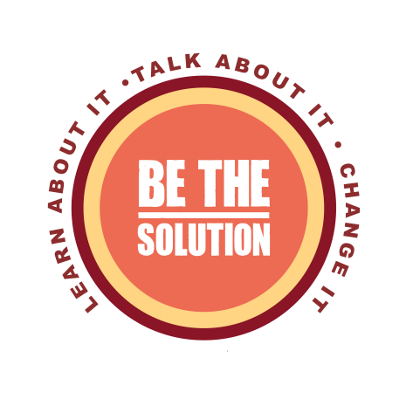The WCADVSA is excited to launch the Wyoming BE THE SOLUTION campaign!

The Wyoming Coalition Against Domestic Violence and Sexual Assault (WCADVSA) adopted the BE THE SOLUTION campaign to raise awareness that sexual violence is perpetrated in Wyoming, but there are actions Wyomingites can take to prevent it from happening in the first place. The message to “Learn about it. Talk about it. Change it” was implemented to engage the population of Wyoming in a cyclical learning and action process to continually learn about sexual violence and prevention, while also asking Wyomingites to take action to change unhealthy norms that permit sexual violence, and, in time, prevent it. Thank you to the Washington Coalition of Sexual Assault Programs (WCSAP) for the use of their BE THE SOLUTION brand. Click [here](http://www.bethesolutionwyo.org) to learn more

about how you can BE THE SOLUTION.

[Learn About It:](http://www.bethesolutionwyo.org/#!learn-about-it/c1sr) Sexual violence is happening across Wyoming. We can take the time to learn about sexual violence and how our attitudes about it influence others. Click [here](http://www.bethesolutionwyo.org/#!learn-about-it/c1sr) to learn more about how you can BE THE SOLUTION

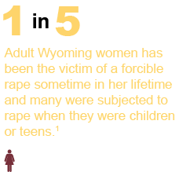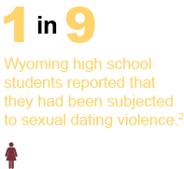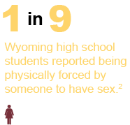

1 Ruggiero, K.J., & Kilpatrick, D.G. (2003).*Rape in Wyoming: A report to the State*. Charleston, SC: National Violence Against Women Prevention Research Center, Medical Univeristy of South Carolina.

2*Centers for Disease Control and Prevention.* (2013). *Yourh Risk Behavior Surveillance.*

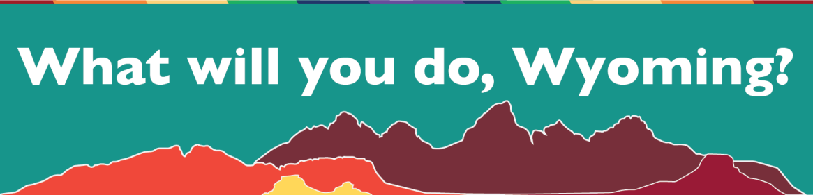

[Talk About it](http://www.bethesolutionwyo.org/#!talk-about-it/c10o3): ​We can have one-on-one conversations about which of our values contribute to sexual violence and which values prevent it

We can talk about:

Healthy relationships and sexuality with our youth, and have these conversations early

on and often;

Why phrases like "boys will be boys" and "you throw like a girl" are harmful;

The impact of violence shown on television and video games with kids; and

How sexual violence affects your community.

Click [here](http://www.bethesolutionwyo.org/#!talk-about-it/c10o3) to learn more about how you can BE THE SOLUTION.

[Change it:](http://www.bethesolutionwyo.org/#!change-it/c11ij) You are the solution when you talk about sexual violence and take a stand against it.

Call out others when they make or laugh at sexist jokes;

Acknowledge that discriminatory behavior and language are connected to sexual

violence; and

Spread the message throughout your community that sexual violence is never okay.

Keep learning about sexual violence, bring the problem up in conversations and challenge values that create unhealthy behaviors. You will lead to change.

Click [here](http://www.bethesolutionwyo.org/#!change-it/c11ij) to learn more about how you can BE THE SOLUTION.

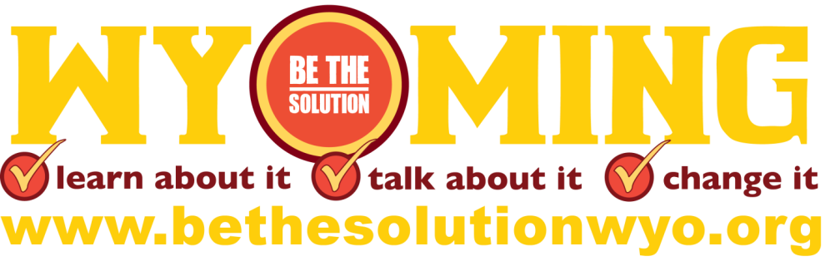

This product was supported by Grant No. 2012-WR-AX-0016 awarded by the Office on Violence Against Women, U.S. Department of Justice.  The opinions, findings, conclusions, and recommendations expressed in this publication are those

of the author(s) and do not necessarily reflect the views of the Department of Justice, Office on Violence Against Women.